UPLOAD CITRIX FILES/SHAREFILE ‘PERSONAL FOLDER’ TO ONEDRIVE

This document is intended for those users who use ShareFile Personal Folders.

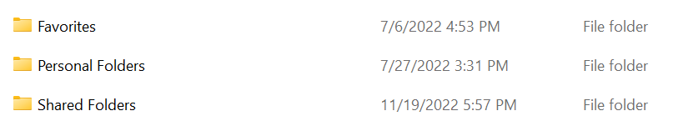

As we continue the migration of our corporate data from ShareFile to OneDrive, we will be relying on our users to migrate the ‘Personal Folders’ folder content to OneDrive themselves. Please review and follow the instructions below to complete this migration.

- Open your default browser (Chrome, Edge) and navigate to your email page (outlook.com/jsco.net)
- Login if necessary:
  - Email address
  - Email password
  - Multi-Factor Authentication tied to your company/reimbursed phone.
- In the upper left-hand corner of the Outlook On-line window, click the ‘App Launcher’ button and select ‘OneDrive’

- Click the ‘Upload’ and ‘Folder’ buttons in the menu ribbon of the OneDrive Window.
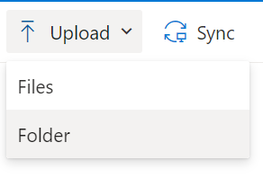
- Navigate to Citrix Files ‘Personal Folders’ and single-click to select
- Click the ‘Upload’ button (see screen-shot next page)
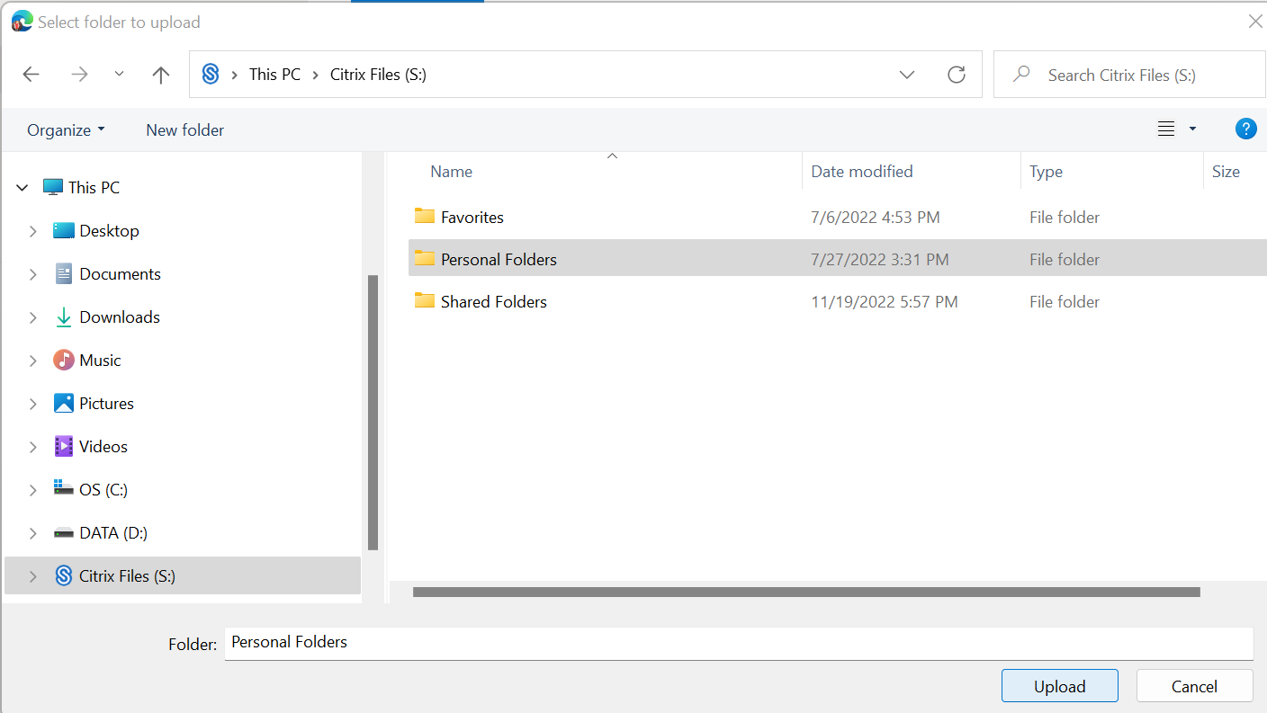
- ‘Personal Folders’ folder will be created and uploaded to OneDrive.

Thank you, and as always, please email support@jsco.net if you have any questions.

