CONFIGURE MICROSOFT OUTLOOK MOBILE

- On your company-issued phone, locate and tap the OUTLOOK APP.
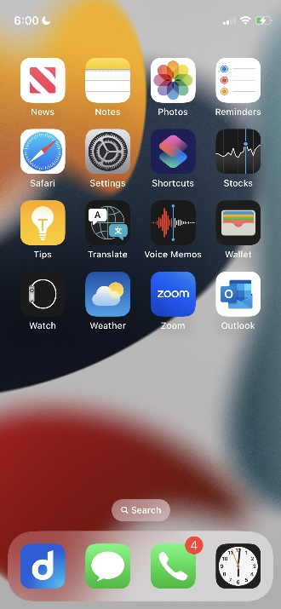
- Tap ADD ACCOUNT.
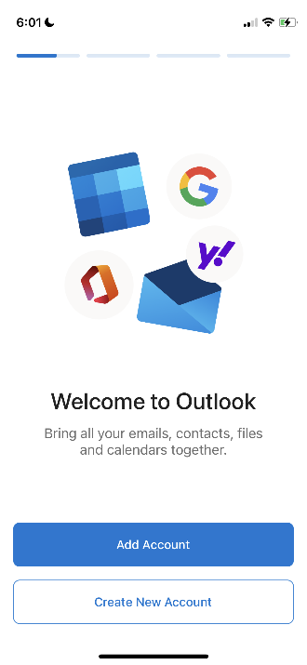
- Enter your email address and tap the ADD ACCOUNT button (screenshot next page).
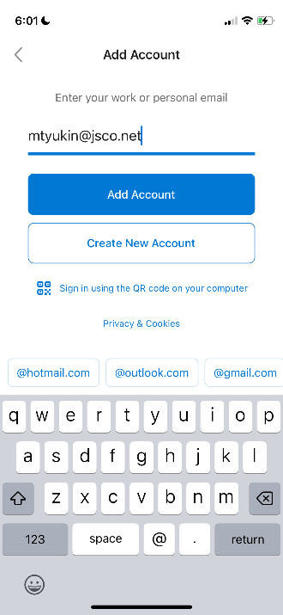
- If your account is already configured with MICROSOFT AUTHENTICATOR, tap the OPEN AUTHENTICATOR button; if not, proceed to step 5. Follow the Microsoft Authenticator steps to authenticate your account.
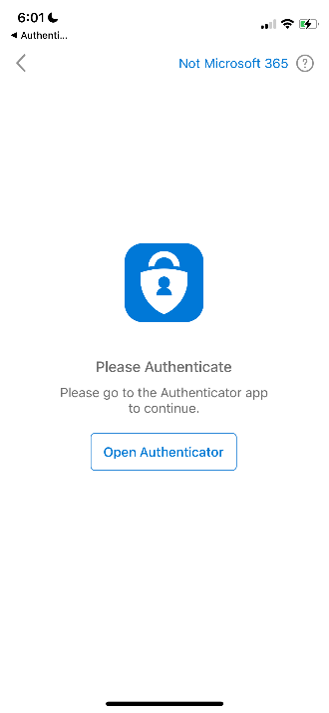
- Tap WORK OR SCHOOL ACCOUNT (screenshot next page)
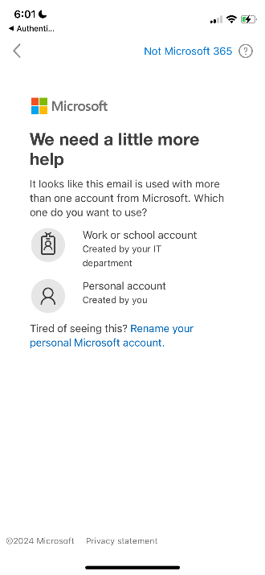
- Enter your EMAIL ACCOUNT PASSWORD and tap the SIGN IN button.
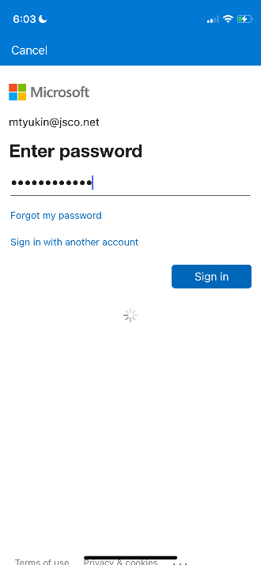
- If your account is protected via MICROSOFT AUTHENTICATOR, follow the prompts to verify the account. You can also tap the SIGN IN ANOTHER WAY link to very the account via TEXT (see screenshot on next page). If you choose to verify via TEXT, select your phone number in the presented options after tapping SIGN IN ANOTHER WAY.
- Enter the code you received via TEXT OF MICROSOFT AUTHENTICATOR.

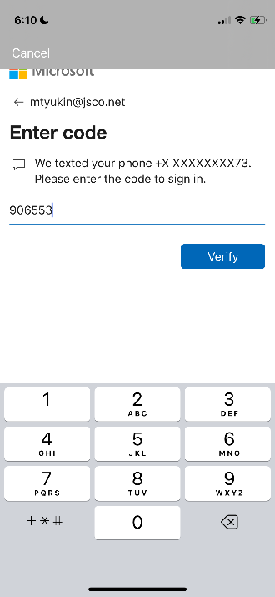
- Tap MAYBE LATER on ADD ANOTHER ACCOUNT screen
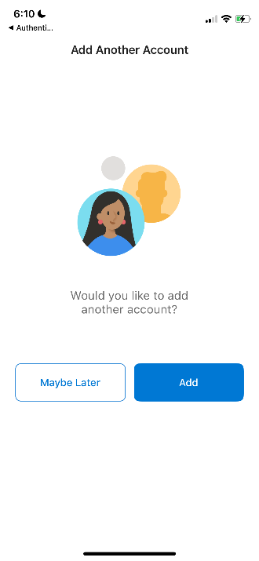
- Your email synch will begin.

If you have any questions, please do not hesitate to contact us at support@jsco.net

