MICROSOFT 365 – MOBILE EMAIL CONFIGURATION

Microsoft Outlook Mobile APP is the recommended application for jsco.net mobile email.
It can be downloaded from Apple APP Store or Google Play Store.



If you are already using the Outlook APP for jsco.net email on your phone, remove the current account before proceeding.

REMOVING CURRENT ACCOUNT IN OUTLOOK APP:
- Open Outlook APP
- Tap the upper left-hand corner - on the CIRCLE (containing the first letter of your first name) immediately to the left of the INBOX
- Tap on the GEAR icon – the bottom left-hand corner
- Under ‘Mail Accounts,’ select currently configured mailbox
- Scroll to the bottom of the resulting page and tap ‘DELETE ACCOUNT.’
- Confirm the deletion

ADDING MICROSOFT 365 EMAIL ACCOUNT IN OUTLOOK APP:
Note: If you have a personal account already configured in your native email client, Outlook may ‘pick up’ this account and suggest configuration. In this case – tap the ‘SKIP’ button.
- Start Outlook App on your phone
- Enter your email address
- Tap ‘Add Account’
- Enter your email password
- Tap ‘Sign in’
- Tap ‘Maybe Later’ to continue to your mailbox

See next page for screen shots.
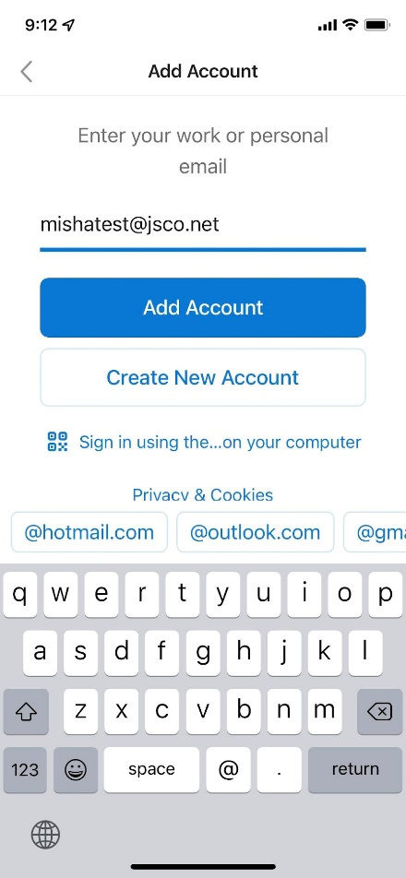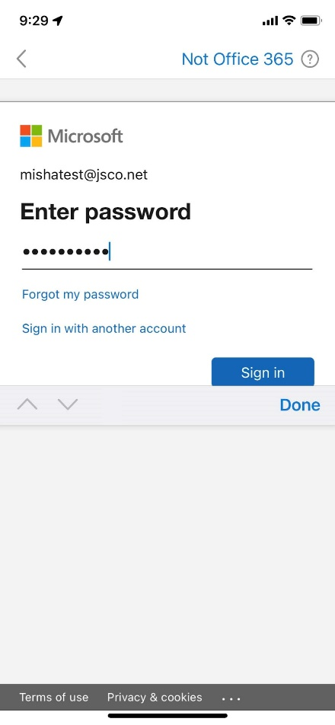
For assistance, please email support@jsco.net or call 415-345-4410

